Task 1.1

Verify kubectl installation

Kubectl is installed:



Get information about cluster

Minicube is installed:

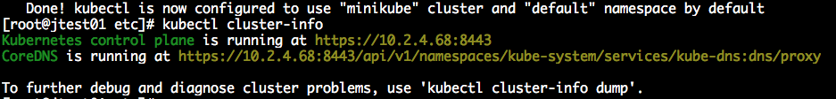

Get information about cluster:

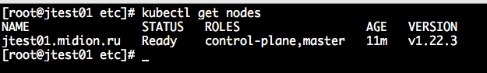

get information about available nodes:

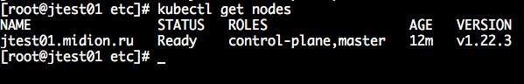

Kubernetes Dashboard is installed

Check kubernetes-dashboard ns:

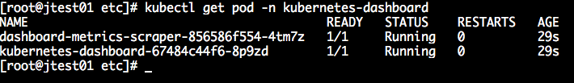

Homework

Create a deployment nginx. Set up two replicas. Remove one of the pods, see what happens.

depl.yaml

apiVersion: apps/v1

kind: Deployment

metadata:

name: nginx-deployment

spec:

replicas: 2

selector:

matchLabels:

app: nginx

template:

metadata:

labels:

app: nginx

spec:

containers:

- image: nginx:latest

name: nginx

1Help 2Save 3Mark 4Replac 5Copy 6Move 7Search 8Delete 9PullDn 10Quit

